1.)Fix the bugs in below snippet  
  
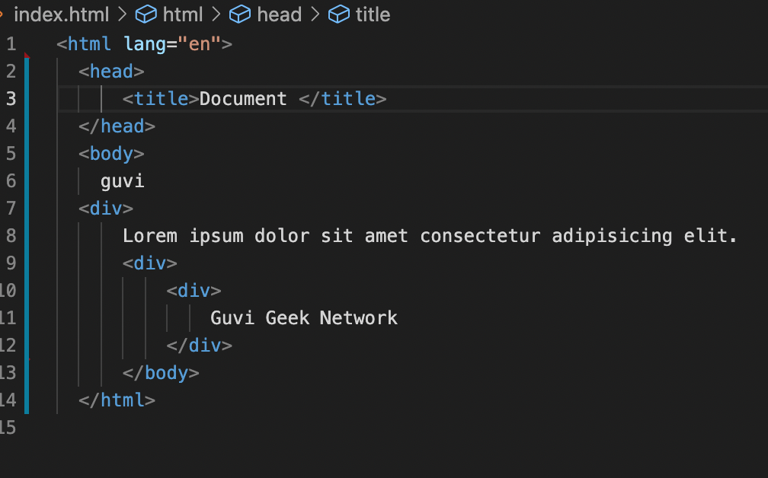

2) Try the below one

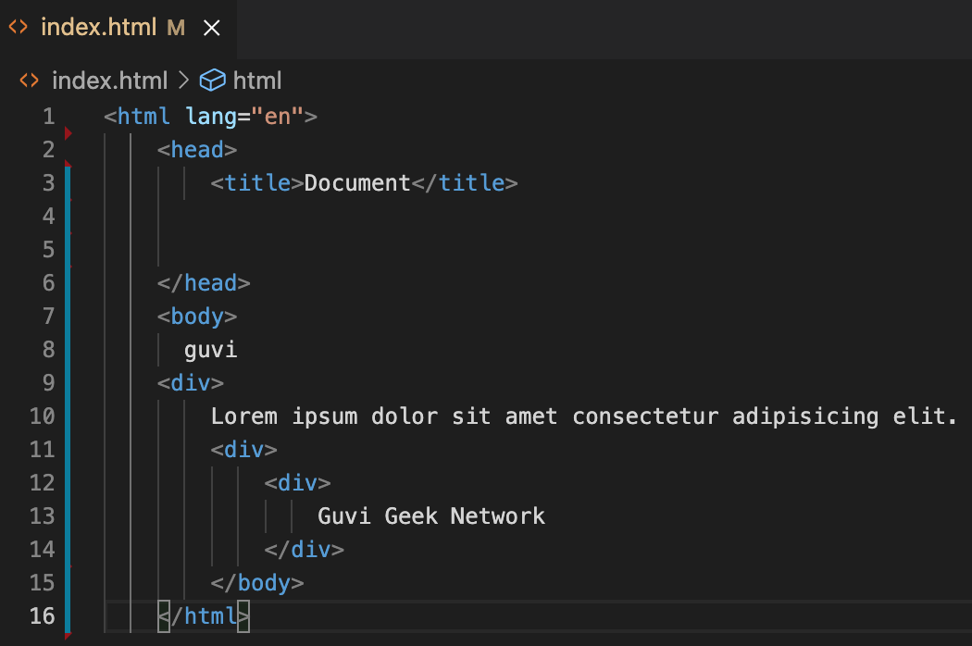

3.Design a contact us form with all fields as required.

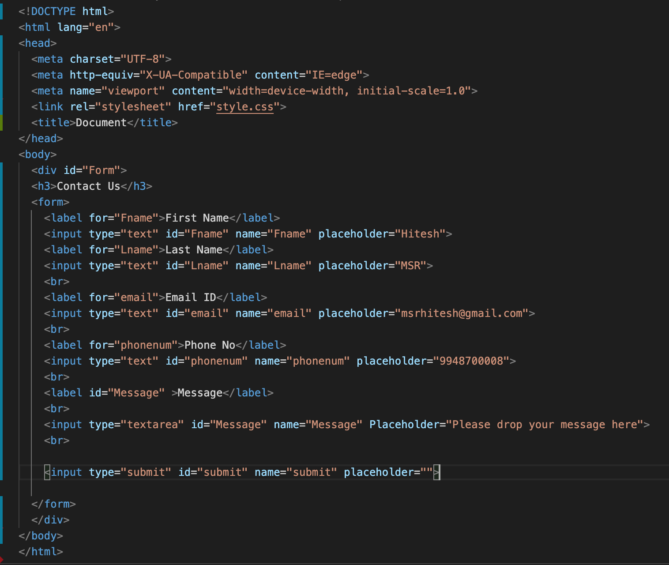 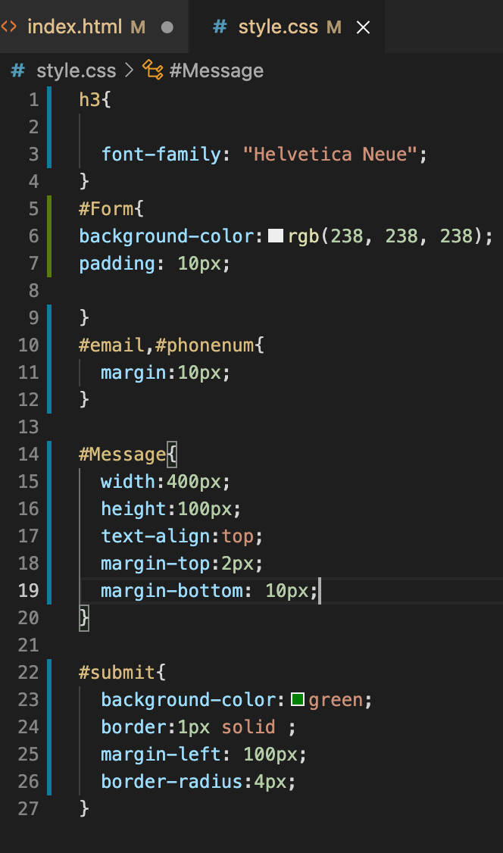

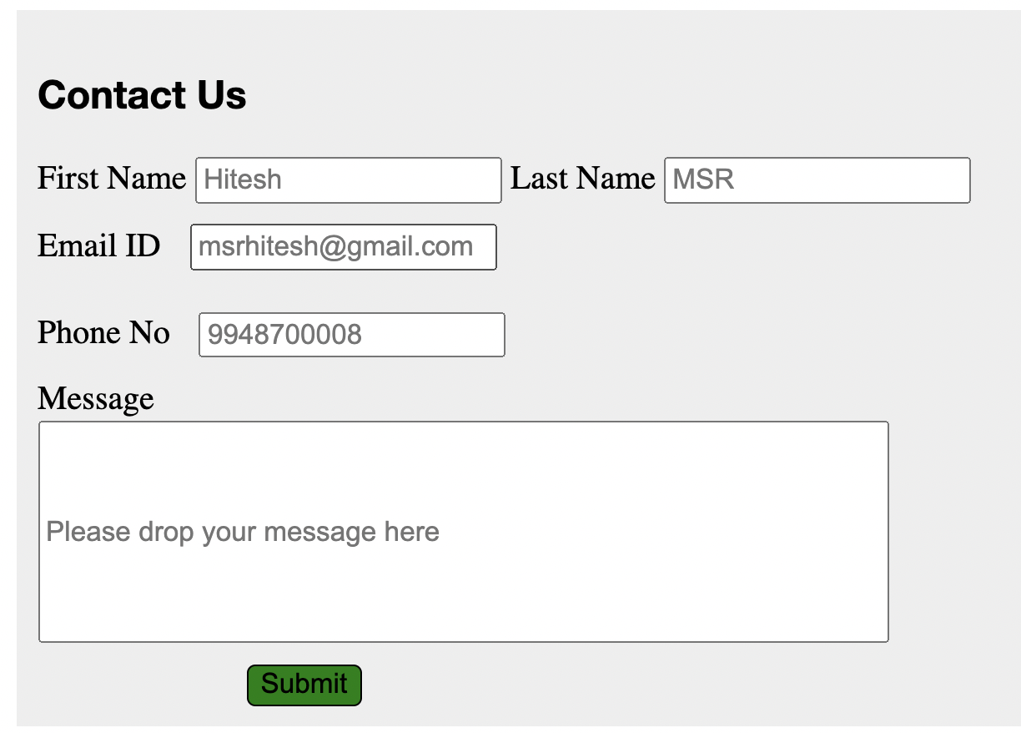

4) Use certain HTML elements to display the following in a HTML page.

**Code:-**

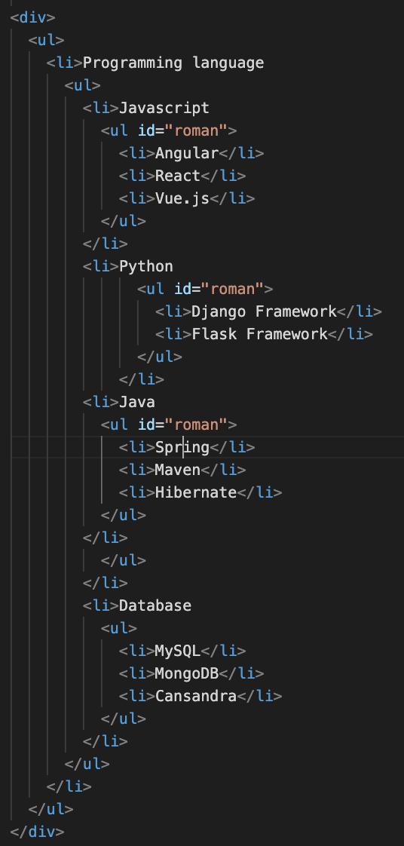  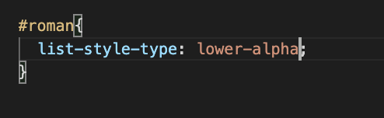

**Output:-**

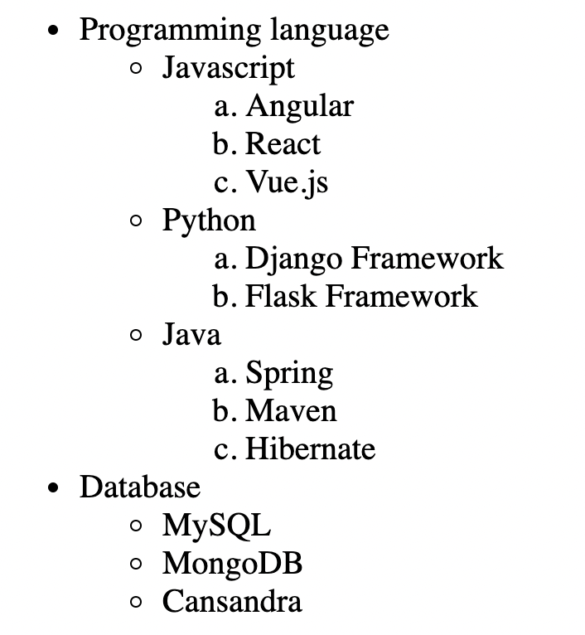

5) Create an element that helps you to open the https://google.com in separate new tab.



6) In the form, add two radio buttons with grouping them for employee type(Salaried and own business)

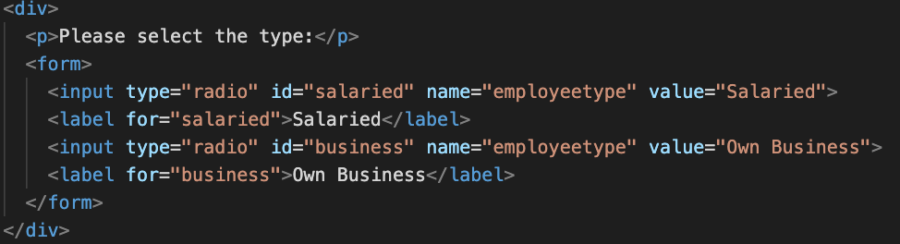 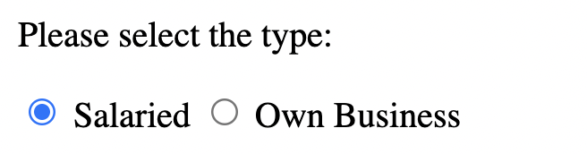

7) Design form shown in the link (<http://evc-cit.info/cit040/formguide/card_0.png>)

**Code:-**

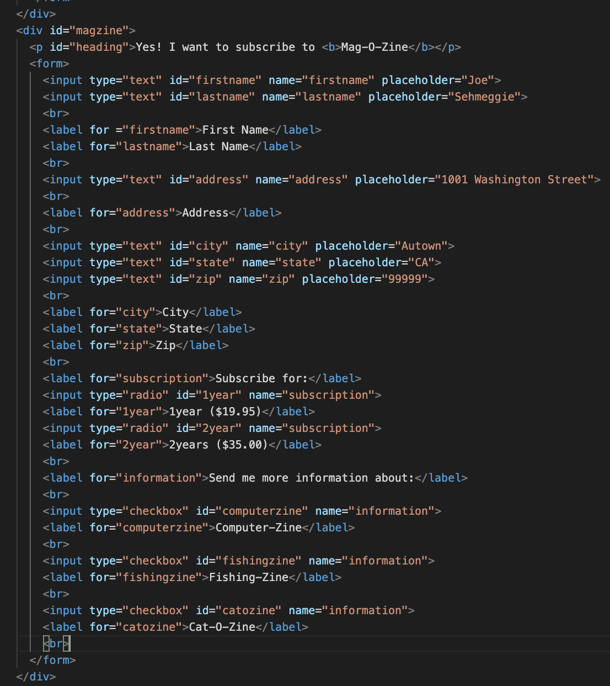 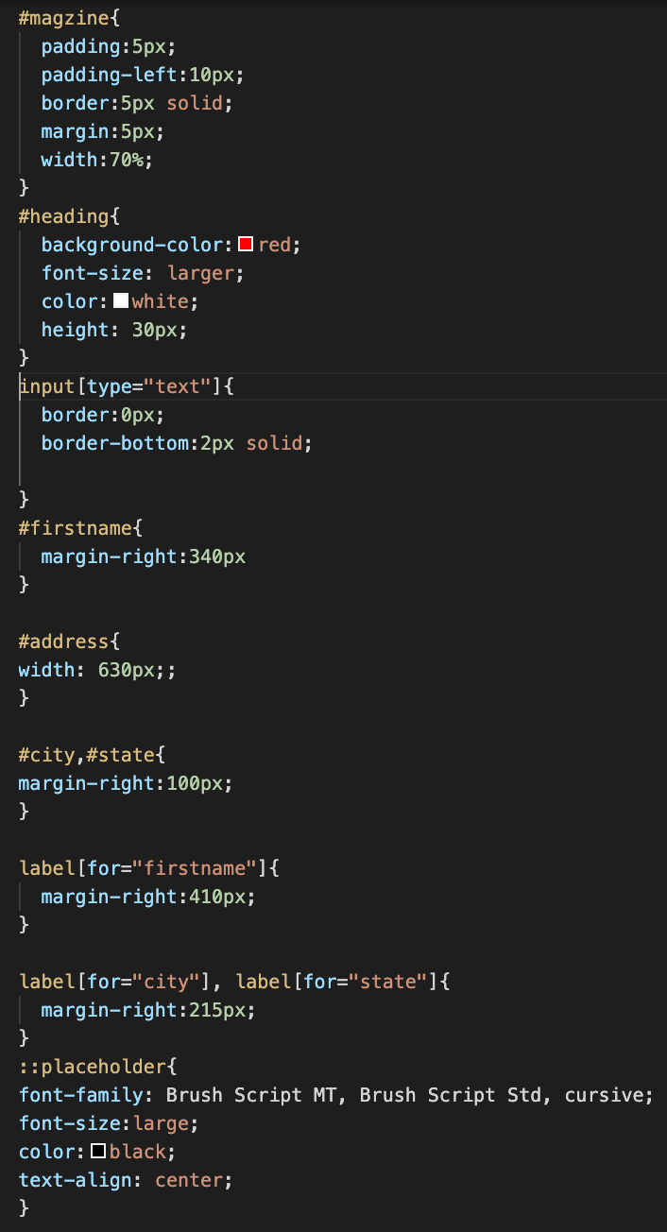

**Output:-**

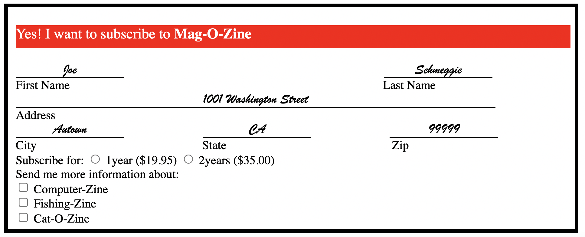

8) Use the table tag to design given image Click here.

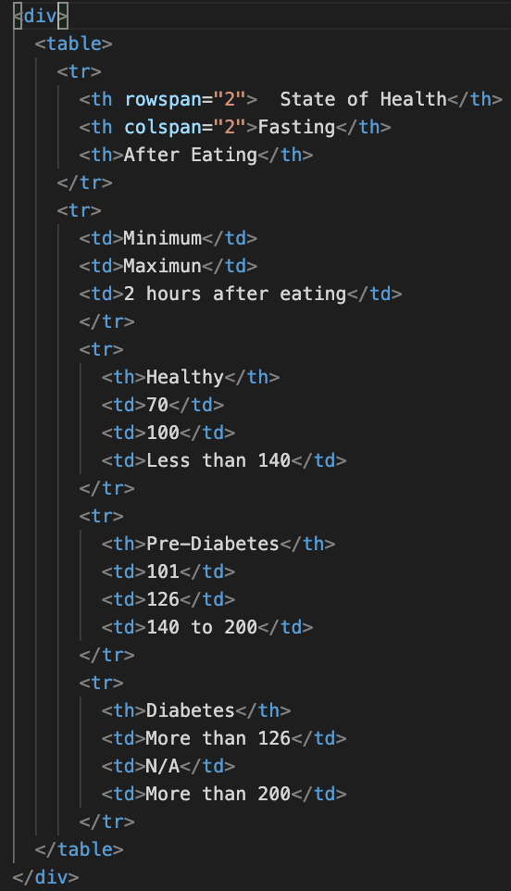 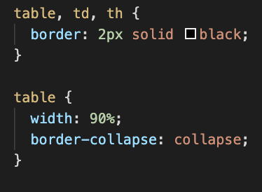

**Output:-**

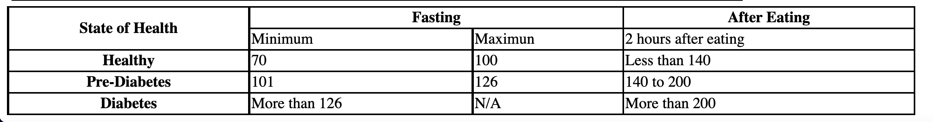

**9) Write HTML input tags snippet to show default values for all Form elements.**

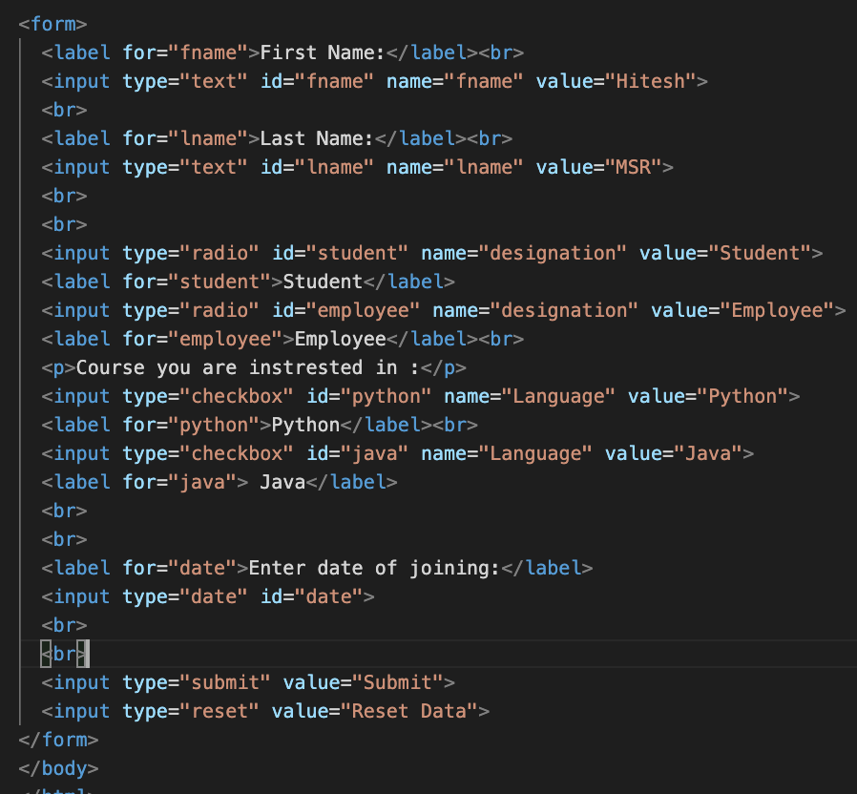

**Output:-**

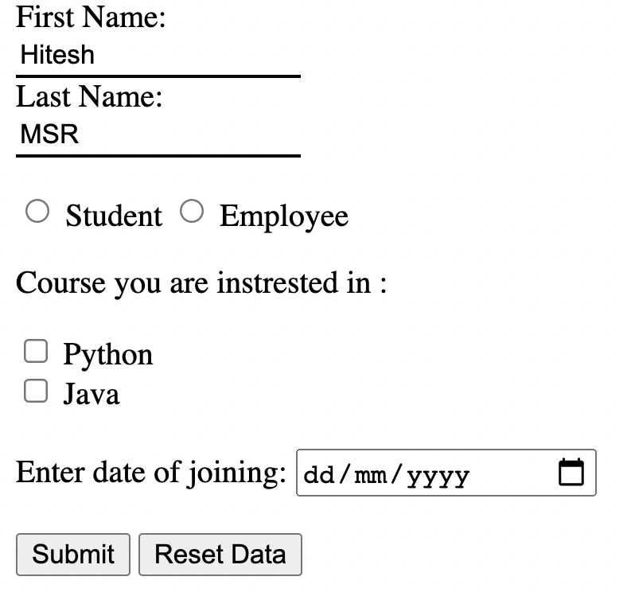

10) In your, HTML page add the below line and Highlight it without using any CSS.

"HTML & CSS is awesome"

Code:-



Output:-

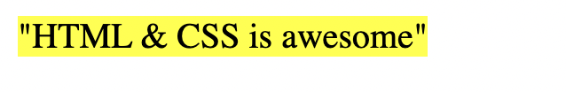

11) Create an HTML page, which should contain all types of input elements.

